PCD KIWANIS 13TH ANNUAL CAR CRUISE AND FALL FESTIVAL
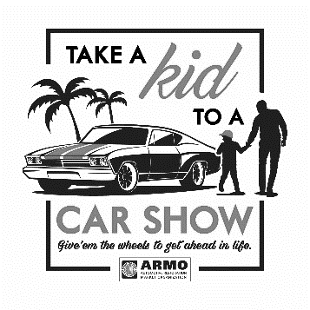
SEPT. 20, 2020
11am - 4pm
Pembroke Town Park, Rt. 77
Next to Pembroke High School ● Rain or Shine
Kids Activities
Huge Basket Raffle by Crossroads House
Variety of Vendors & Food Trucks
For Vendor Info – Call Penny at 585-356-3413
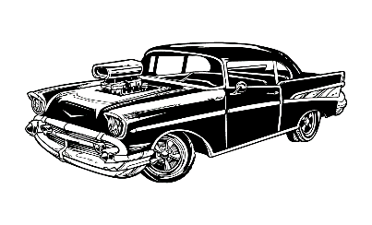
email: pcdkiwanis@gmail.com ● www.pcdkiwanis.com
Cruise Registration starts 9 a.m.
Pre-Registration fee $10 per car
$15 Registration day of the cruise for all participants not pre-registered
Proceeds benefit PCD Kiwanis Kids Projects in our community
Unique Dash Plaques/Goody bags only guaranteed for first 100 cars
Participant Vote – Trophies awarded at 3pm
Raffles, Music, Food Available
2nd ANNUAL FREE KIDS CAR CRUISE (8 yrs. and under) 11A-1P
Kids register your ride-on vehicle and get a kid’s goody bag
Car Cruise Info - Call John at 716-937-9918 or email: drogicd@gmail.com
* * * * * * * * * * * * * * * *
Name Address City
State Zip Phone E-mail
Year Make Model
* Vehicle owner assumes liability for vehicle damage*
Pre-Registration $10 per vehicle by 9/10/20 - TOTAL ENCLOSED $_______________
Please mail form and check to: make check payable to PCD Kiwanis Club
PCD Kiwanis Club, Attn: Car Cruise Registration, 470 Sumner Road, Corfu, NY 14036

